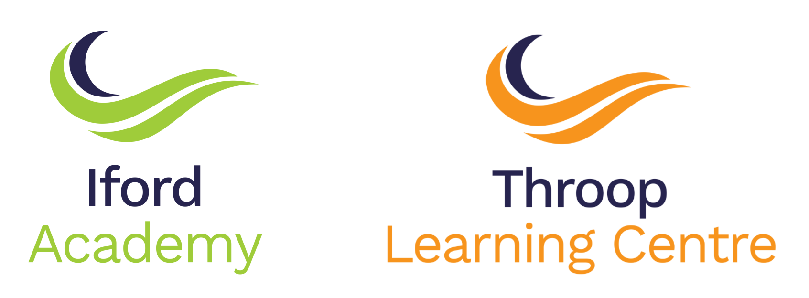

PSHE & RSE POLICY

SCOPE: | Academy Policy
AUTHOR/ORIGINATOR: | Principal
NAME OF RESPONSIBLE DIRECTOR/PRINCIPAL: | Academy Principal & Sector Director
APPROVING COMMITTEE: | Academy Committee
STATUTORY BASIS: | Statutory Policy
REQUIREMENT TO PUBLISH ON WEBSITE: | Yes
DATE CONSULTED ON BY JCNC: | n/a
DATE RATIFIED BY APPROVING COMMITTEE: | 22nd March 2022
REVIEW PERIOD:
DATE OF INTERIM REVIEW:
DATE DUE FOR NEXT REVIEW:
REFERENCE NUMBER: | To be added by Trust
DATE DISTRIBUTED | To be added by Trust

Outstanding Achievement for All

PSHE & RSE
POLICY

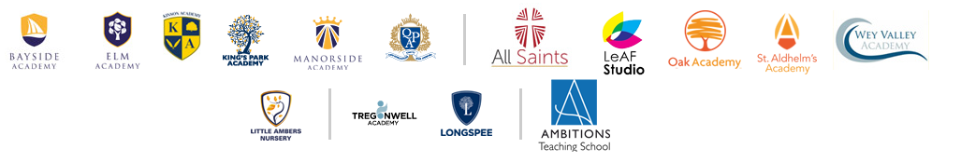

Contents
Aims of PSHE ………………………………………………………………………………………………3
Statutory RSE and Health Education ……………………………………………………………3
Safeguarding and Responsibility …………………………………………………………………5
Equality ………………………………………………………………………………………………………5
SEND ……………………………………………………………………………………………………….….5
Assessing …………………………………………………………………………………………………….5
Roles and Responsibilities …………………………………………………………………………..6
Parents Right to Withdraw ………………………………………………………………………...6
Visitors ……………………………………………………………………………………………………….7
Curriculum Design ………………………………………………………………………………………7
Policy Review …………………………………………………………………………………………....8

AIMS OF PSHE
Ambitions Academies Trust aims to teach Personal, Social and Health Education using a whole-school approach with the aim of creating a community and environment that respects, supports and encourages each pupil.
Under section 78 of the Education Act 2002 and the Academies Act 2010, the PSHE curriculum must
- Promote the spiritual, moral, cultural, mental and physical development of pupils at the school and of society.
- Prepare pupils at the school for the opportunities, responsibilities and experiences of later life.
Ambitions Academies Trust takes a comprehensive approach towards PSHE, providing a programme which offers a diligently devised Scheme of Work across all year groups supporting the development and learning capacity of each pupil.
PSHE makes a significant contribution to the promotion of young people’s personal and social development. This is an essential aspect of education, supporting learning across all curriculum areas. Through the promotion of PSHE, skills are developed that our pupils need in order for them to grow and flourish as individuals and members of society. Studying PSHE contributes to helping children and young people to build their personal identities, confidence and self-esteem. It helps them to make career choices, understand managing their finances and what influences their decision making process. PSHE enables them to recognise and manage their emotions and to communicate positively in a range of different scenarios. Overall, the PSHE curriculum at Ambitions Academies Trust supports the ‘Personal Development’ and ‘Behaviour and Attitude’ aspects required under the Ofsted Inspection Framework, as well as contributing significantly to the Safeguarding and Equality Duties, the Government’s British Values agenda and the Spiritual, Moral, Social, Cultural (SMSC) opportunities provided to all pupils.

STATUTORY RSE AND HEALTH EDUCATION

Relationships education, Relationships and Sex Education and Health Education (England) Regulations 2019, made under section 34 and 35 of the Children and Social Work Act 2017, make Relationships and Sex Education (RSE) compulsory for all pupils receiving secondary education.
“Today’s children and young people are growing up in an increasingly complex world and living their lives seamlessly on and offline. This presents many positive and exciting opportunities, but also challenges and risks. In this environment, children and young people need to know how to be safe and healthy, and how to manage their academic, personal and social lives in a positive way.”

“This is why we have made Relationships Education compulsory in all primary schools in England and Relationships and Sex Education compulsory in all secondary schools, as well as making Health Education compulsory in all state-funded schools.”

“In primary schools, we want the subjects to put in place the key building blocks of healthy, respectful relationships, focusing on family and friendships, in all contexts, including online. This will sit alongside the essential understanding of how to be healthy. At secondary, teaching will build on the knowledge acquired at primary and develop further pupils’ understanding of health, with an increased focus on risk areas such as drugs and alcohol, as well as introducing knowledge about intimate relationships and sex.”

“These subjects represent a huge opportunity to help our children and young people develop. The knowledge and attributes gained will support their own, and others’ wellbeing and attainment and help young people to become successful and happy adults who make a meaningful contribution to society.”

Secretary of State Foreword, Relationships Education, Relationships and Sex Education (RSE) and Health Education. DfE Guidance 2019 p.4-5.

“Schools are free to determine how to deliver the content set out in the DfE guidance 2019 in the context of a broad and balanced curriculum. Effective teaching in these subjects will ensure that core knowledge is broken down into units of manageable size and communicated clearly to pupils, in a carefully sequenced way, within a planned programme of lessons.”

Relationships Education, Relationships and Sex Education (RSE) and Health Education.
DfE Guidance p.8

“All schools must have in place a written policy for Relationships and Sex Education.”

Relationships Education, Relationships and Sex Education (RSE) and Health Education.
DfE Guidance p.11.

The DfE Guidance 2019 at secondary school level relates to the ‘intimate and sexual relationships, including sexual health’ section of the guidance and includes:
- Facts about reproductive health
- Facts about the full range of contraceptive choices
- How sexually transmitted infections (STIs) including HIV/AIDS are transmitted
- How to get further advice, including how and where to access confidential sexual and reproductive health advice and treatment
- Consent and the law

Relationships Education, Relationships and Sex Education (RSE) and Health Education.
DfE Guidance page29

Ambitions Academies Trust include the statutory Relationships, Sex and Health Education within the PSHE curriculum as our pupils need help and advice to help them develop healthy relationships, not just those of an intimate nature, but of all kinds.
We aim to help them understand what a healthy relationship looks like and teach them what is and is not acceptable behaviour. We want to enable our pupils to understand and respect who they are and empower them with a voice which enables them to act according to their beliefs and that supports them throughout their lives.

SAFEGUARDING AND RESPONSIBILITY
PSHE and RSE work with pupils’ real-life experiences and it is key that both staff and pupils are protected in these lessons. A safe and supportive environment is created by the use of ground rules;
- Listen to each other (only one person talks at a time)
- Keep to time
- Challenge the statement; not the individual making it
- The ‘right’ not to answer questions
- No personal questions to be asked by pupils or teachers
- If giving an example make it anonymous.
- Everyone has a right to his or her own space.
- Right to Privacy.
Many issues covered in PSHE and RSE are of a sensitive nature. The ground rules provide a safe working environment for both pupils and staff. All staff at the Ambitions Academies Trust receive safeguarding training.
Due to nature of the topics covered in the PSHE and RSE education programmes, all teachers are made aware of the Ambitions Academies Trust guidelines on confidentiality and disclosure. The boundaries around confidentiality are made explicit to learners.
EQUALITY

The PSHE and RSE policy at Ambitions Academies Trust promotes respect and value for each individual pupil. The DfE Guidance 2019 (p.15) states, “Schools should ensure that the needs of all pupils are appropriately met, and that all pupils understand the importance of equality and respect. Schools must ensure they comply with the relevant provisions of the Equality Act 2010 under which sexual orientation and gender reassignment are amongst the protected characteristics. Schools within the Trust are free to determine how and when they teach the pupils about LGBT content (Lesbian, Gay, Bisexual, Transgender) and all pupils are taught the LGBT content at a timely point as part of the curriculum.

At Ambitions Academies Trust, we respect the right of pupils, their families and our staff, to hold beliefs, religious or otherwise, and understand that sometimes these may be different with our approach to some aspects of RSE and Health Education.

SEND

Ambitions Academies Trust prides itself on its inclusive policy and how we make provision for all pupils’ needs. This is no exception for PSHE and RSE. High quality teaching is differentiated and personalised to meet the needs of all pupils.

ASSESSING

As with any learning, the assessment of pupils’ PSHE and RSE is important as it enables the teacher to gauge their progress and it also informs the development of the lessons. Pupils do not pass or fail this area of learning, but have the opportunity to reflect upon their personal learning experience, set goals, and record their understanding in a range of ways; posters, leaflets, reflective diaries etc. Their progress is also monitored during class discussions, group work, questionnaires / surveys and peer assessment. Pupil voice is also used to adapt and amend material for PSHE and RSE and ensure it is relevant and effective to both our learners and wider community.

ROLES AND RESPONSIBILIES

The Academies Advisory Committee
The PSHE and RSE policy will be approved by Ambitions Academies Trust governing body and they will hold the Principals to account for its implementation.

The Principal
It is the responsibility of the Principal to ensure that PSHE and RSE is taught consistently across the school.

It is also their responsibility to manage any requests to withdraw pupils from non-statutory components of RSE

Staff
The staff across Ambitions Academies Trust are responsible for:
- The delivery of PSHE and RSE in a sensitive way
- Modelling positive attitudes to PSHE and RSE
- Monitoring progress
- Responding to the needs of individual pupils
- Responding appropriately to pupils whose parents / carers wish them to be withdrawn from the non-statutory components of RSE

Staff do not have the right to opt out of teaching RSE. Staff who have concerns about teaching RSE are encouraged to discuss this with the Principal.
Pupils
There is an expectation that all pupils across the Ambitions Academies Trust fully engage in PSHE and RSE and follow the ground rules (as specified above) thus ensuring they treat others with respect and sensitivity.
Parents
All parents have access to the PSHE and RSE policy and are invited to feedback directly to the school and participate with surveys and questionnaires as part of our consultation process.

PARENTS RIGHT TO WITHDRAW FROM RSE

Primary schools
Parents’ do not have the right to withdraw their children from relationships education.
Parents’ have the right to withdraw their children from the non-statutory components of sex education within RSE. Requests for withdrawal should be put in writing using the form found in Appendix 2 of this policy and addressed to the Principal. Alternative work will be given to pupils who are withdrawn from sex education.

Secondary schools
Parents’ have the right to withdraw their child from the non-statutory components of sex education within RSE up to and until 3 terms before the child turns 16. After this point, if the child wished to receive sex education rather than being withdrawn, the school will arrange this.
Requests for withdrawal should be put in writing using the form found in Appendix 2 of this policy and addressed to the Principal.
A copy of withdrawal requests will be placed in the pupil’s educational record. The Principal will discuss the request with the parents and take appropriate action. Alternative work will be given to pupils who are withdrawn from sex education.

VISITORS

Ambitions Academies Trust value working with external partners as they enhance the delivery of PSHE and RSE with specialist knowledge and different ways of engaging our pupils. As part of the PSHE and RSE educational package, outside visitors will be invited to deliver appropriate sessions to pupils within the Trust.
All visitors are subject to the Trust’s Child Protection and Safeguarding policy and the credentials of visiting organisations and any visitors linked to external agencies are always checked. The Trust also ensures that the teaching delivered by visitors fits with the planned programme of study. The content of lessons provided by external agencies is age appropriate and accessible for all pupils and is approved by the school in advance of delivery.
As with all PSHE and RSE lessons, The Trust will ensure that guest speakers / visitors are aware of the confidentiality and safeguarding policy. Any matters reported by visitors to the lead teacher will be dealt with in line with the Trust’s Safeguarding Policy

CURRICULUM DESIGN

Our curriculum is set out as per Appendix 1 but we may need to adapt it as and when necessary.
We have developed the curriculum in consultation with parents, pupils and staff, taking into account the age, needs and feelings of pupils. If pupils ask questions outside the scope of this policy, teachers will respond in an appropriate manner so they are fully informed and don’t seek answers online.

POLICY REVIEW

Policy Name | PSHE and RSE Policy
Author
Statutory, regulatory and/or contractual considerations | Statutory
Implementation Date | September 2020
Review Date | September 2021
Review Cycle | Annually

The PSHE and RSE policy at the Ambitions Academies Trust is informed by the DfE guidance:
- Keeping Children Safe in Education
- Respectful School Communities
- Behaviour and Discipline in Schools
- Equalities Act 2010
- SEND code of practice: 0 to 25 years]
- Mental Health and Behaviour in Schools
- Preventing and Tackling Bullying including cyberbullying
- Sexual violence and sexual harassment between children in schools
- The Equality and Human Rights Commission Advice and Guidance
- Promoting Fundamental British Values as part of SMSC in schools

Appendix 1:
Iford Academy & Throop Learning Centre
PSHE Curriculum outline
The school uses the Jigsaw Programme to deliver PSHE across the Academy.

At key stage 3, students build on the knowledge and understanding, skills, attributes and values they have acquired and developed during the primary phase. PSH/RS education acknowledges and addresses the changes that young people experience, beginning with the transition to secondary school, the challenges of adolescence and their increasing independence. It teaches the knowledge and skills which will equip them for the opportunities and challenges of life. Students learn to manage diverse relationships, their online lives, and the increasing influence of peers and the media.
At key stage 4, students deepen knowledge and understanding, extend and rehearse skills, and further explore attitudes, values and attributes acquired during key stage 3. CPD education reflects the fact that students are moving towards an independent role in adult life, taking on greater responsibility for themselves and others.
The PSHE programme supports the academy vision of preparing pupils for a safe, happy and productive adult life.
Core Themes
- Self-Concept
- Mental Health and Wellbeing
- Healthy Life Styles
- Drugs, Alcohol and Tobacco
- Managing Risks and Personal Safety
- Puberty and Sexual Health
- Positive Relationships
- Relationship Values
- Forming and Maintaining Respectful Relationships
- Consent
- Contraception and Parenthood
- Bullying, Abuse and Discrimination
- Social Influences
- Learning Skills
- Choices and Pathways
- Work and Career
- Employment Rights and Responsibilities
- Financial Choices
- Media Literacy and Digital Resilience

The PSHE programme is part of a wider strategy to support pupils developing their Personal, social development, where pupil are provided with opportunities to develop aspects of Leadership, Organisation, Resilience, Initiative and communication. It also compliments and extends the Careers programme at the academy.

Appendix 2: Parent form: withdrawal from sex education within RSE

To be completed by parents
Name of child |  | Class
Name of parent |  | Date
Reason for withdrawing from sex education within relationships and sex education
Any other information you would like the school to consider
Parent signature

To be completed by the school
Agreed actions from discussion with parents

